Generate Signed APK along with ProGuard protected:

**Step 1:** Code snippet that enable proguard code shrinking.

android {

buildTypes {

release {

minifyEnabled true

proguardFiles getDefaultProguardFile(‘proguard-android.txt'),

'proguard-rules.pro'

}

}

...

}

**Step 2:** Go to Gradle Task in right panel of Android Studio and search for assembleRelease

or assemble(#your_defined_buildtype) under Module Tasks.

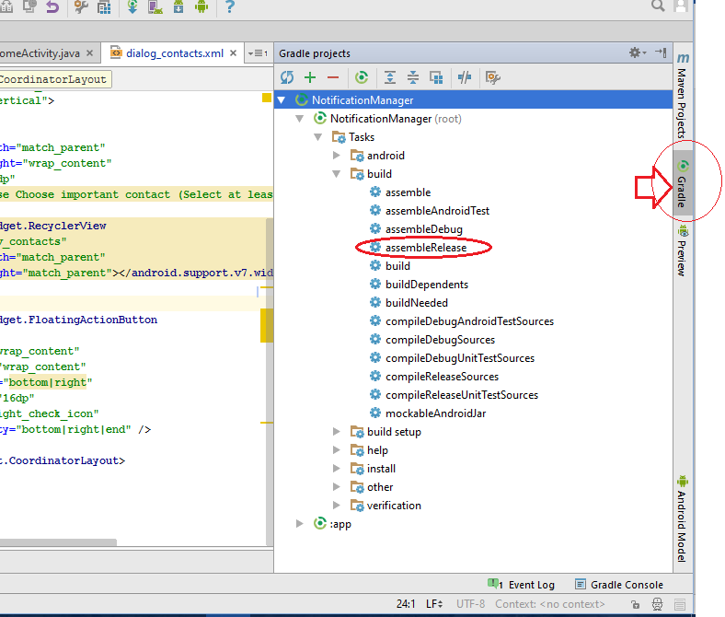

**Step 3:** Go to Build Variant in Left Panel and select the build from drop down.

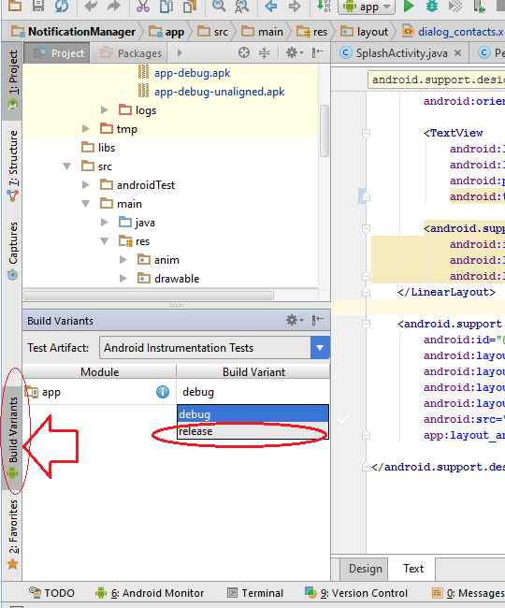

**Step 3:** Go to **Build > Generate Signed APK** option and follow the steps which required for key store.

